**STEP’S TO CREATE A VM IN VCENTRE**

Deploying a virtual machine from a template creates a virtual machine that is a copy of the template. The new virtual machine has the virtual hardware, installed software, and other properties that are configured from the template.

1) Open vSphere Client Console in google chrome

2) Next click on VMs and Templates

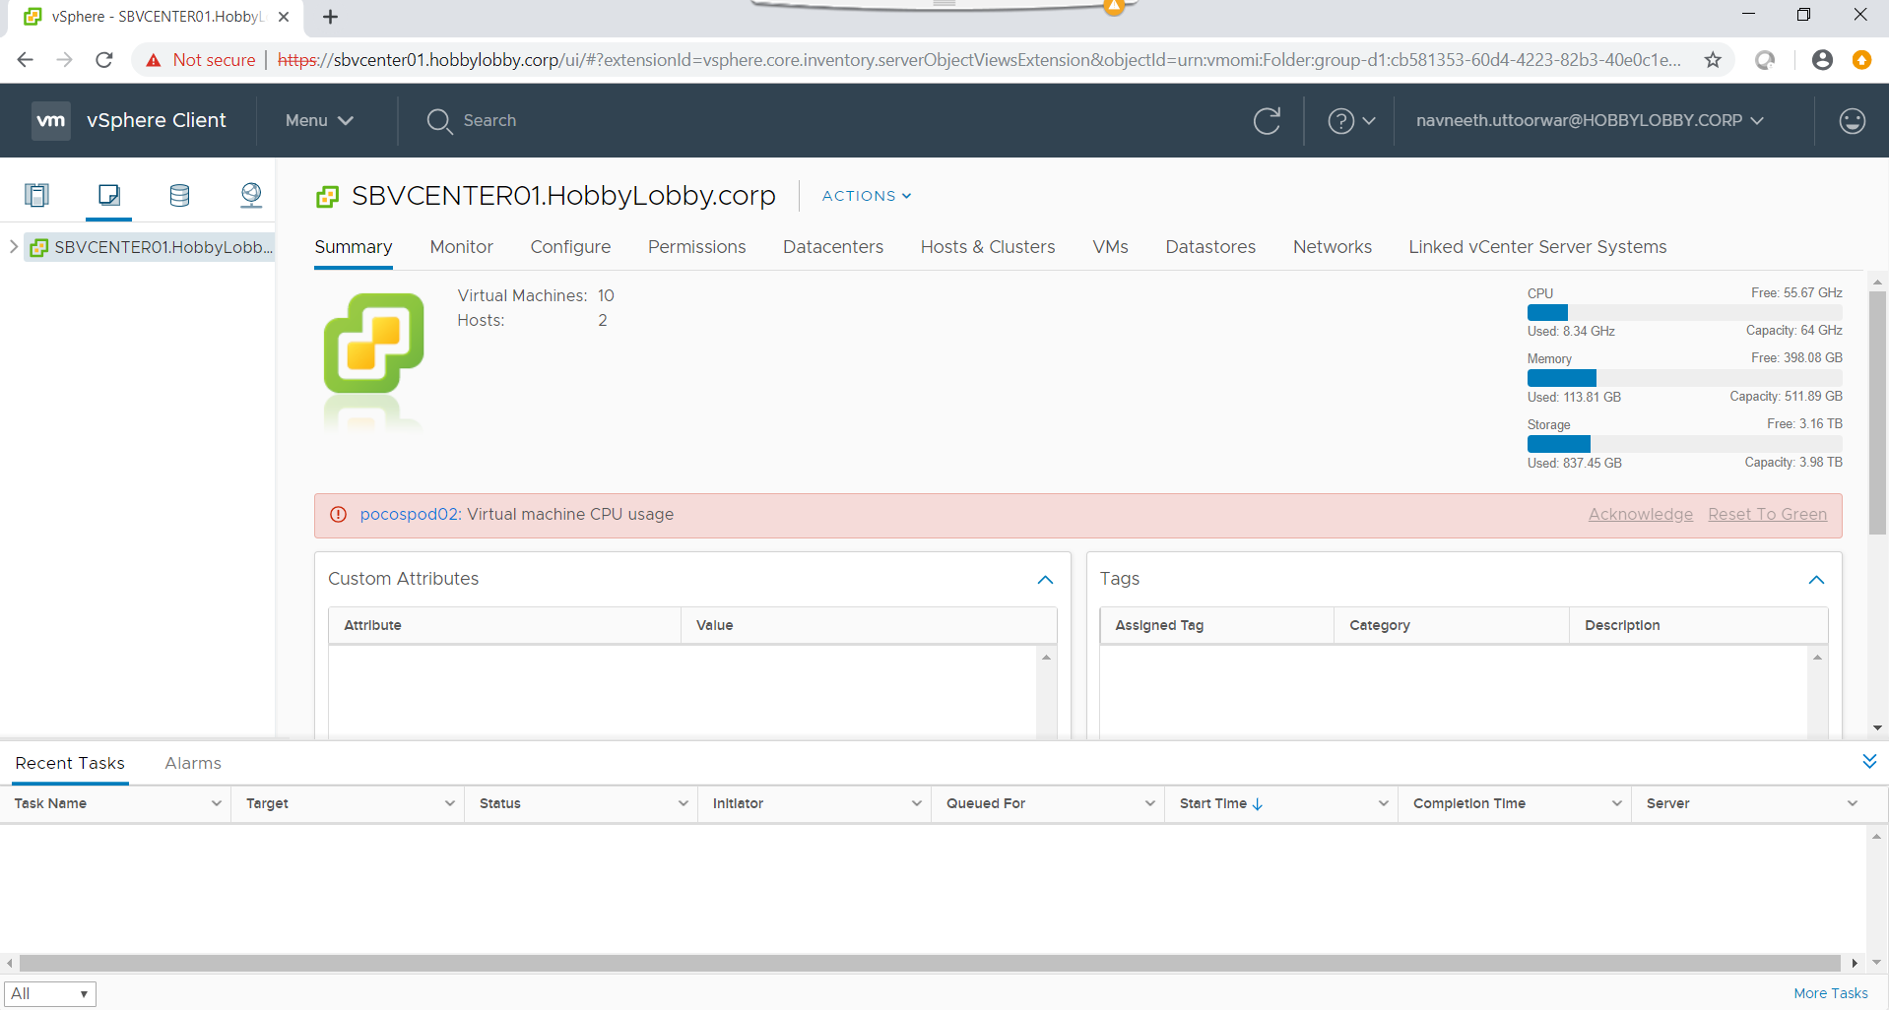

3) Here we should Extend the SBVCENTER01.HobbyLobby.corp and select the hypervisor.

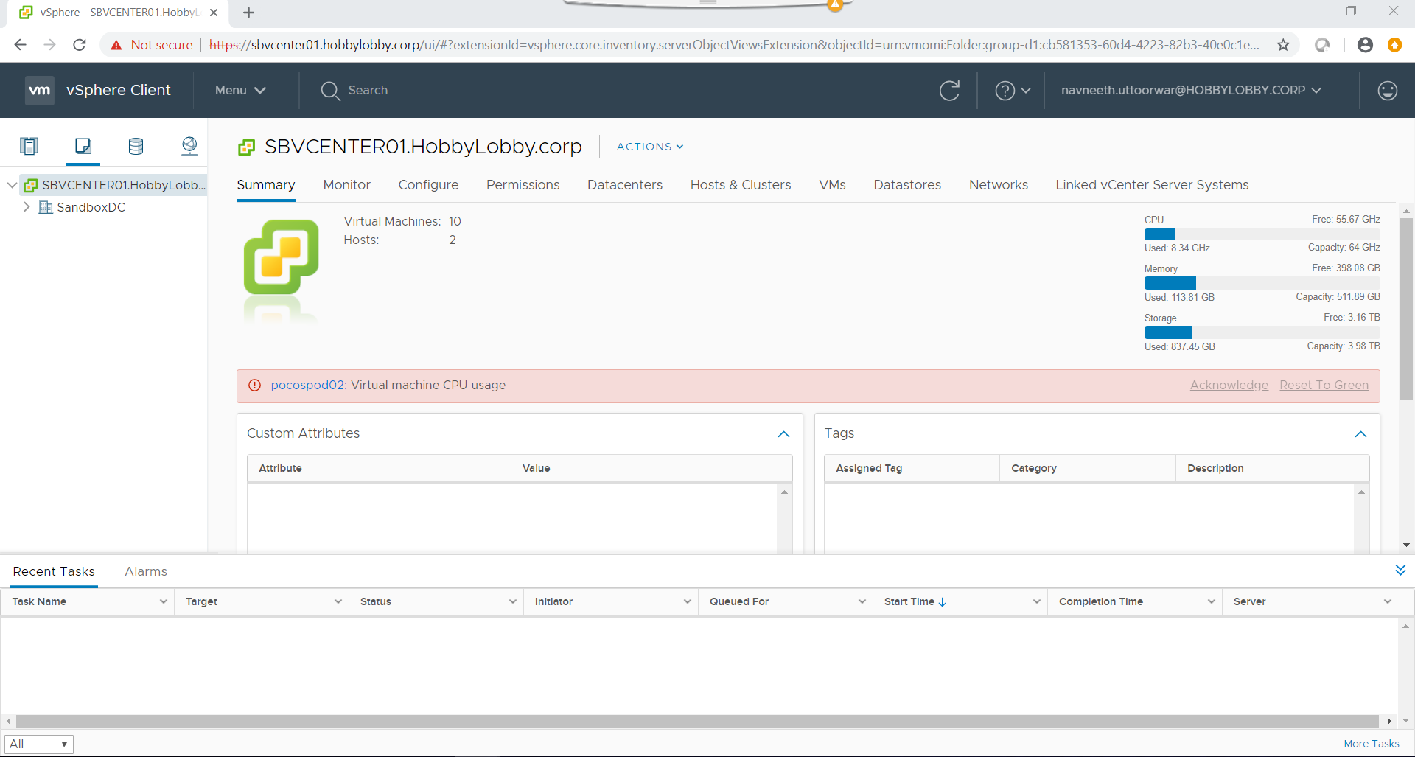

4) In the hypervisor create your own folder. Example:SandboxDC in the hypervisor and openshift folder.

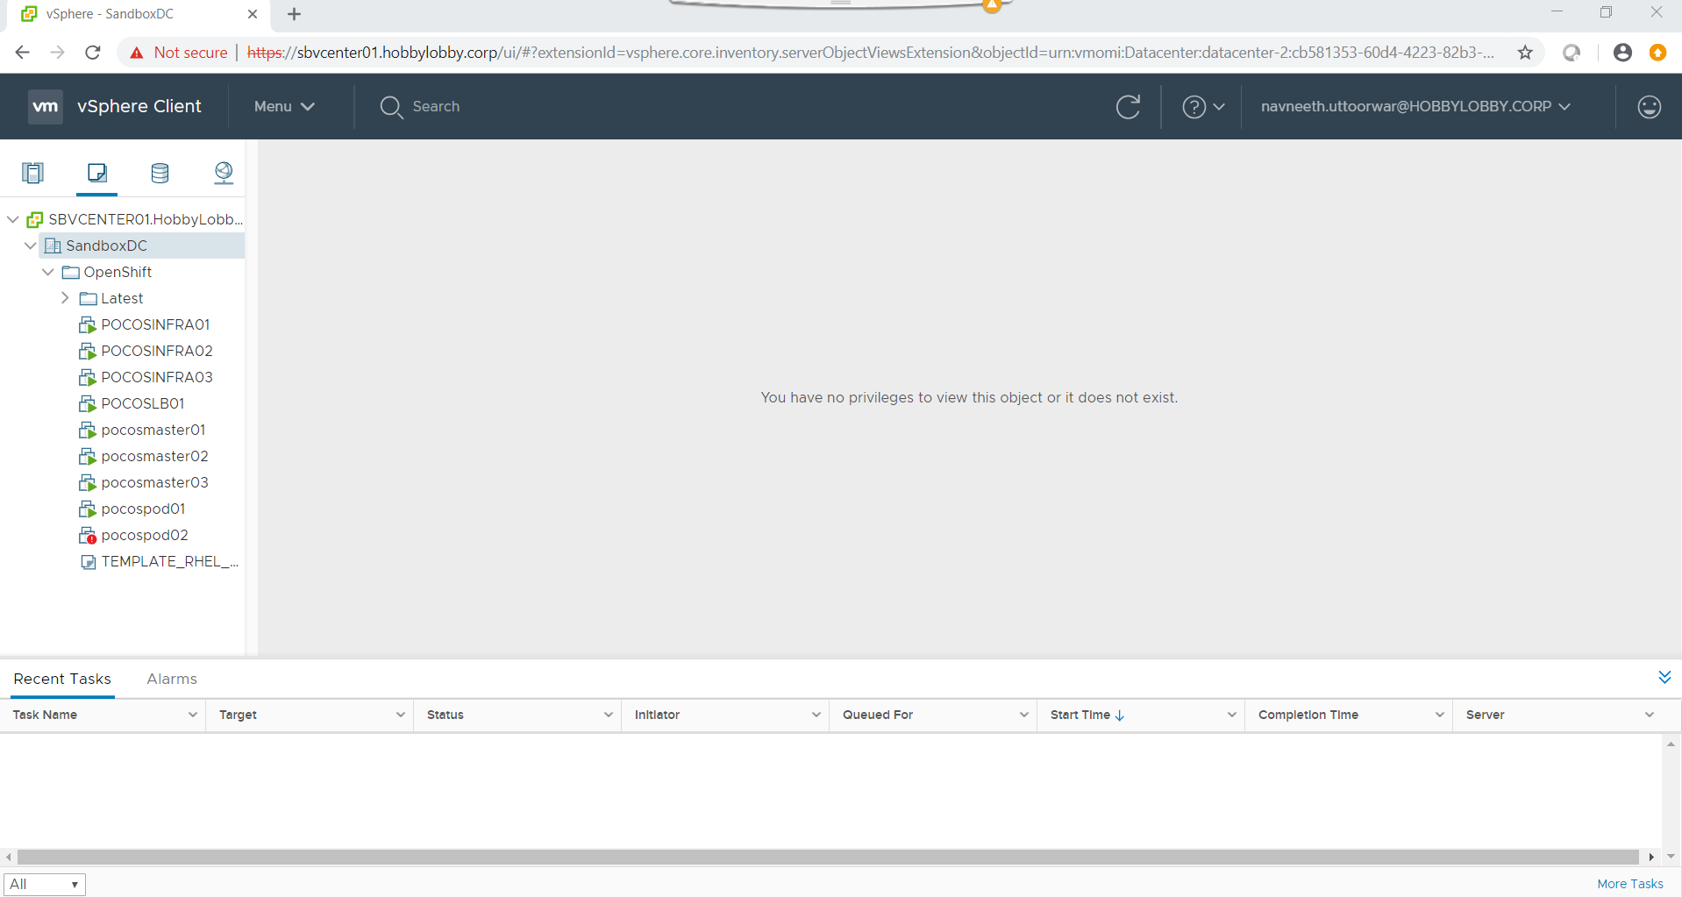

5) Select SandboxDC > OpenShift > Latest > TEMPLATE_RHEL_7.6 > New VM from this Template.

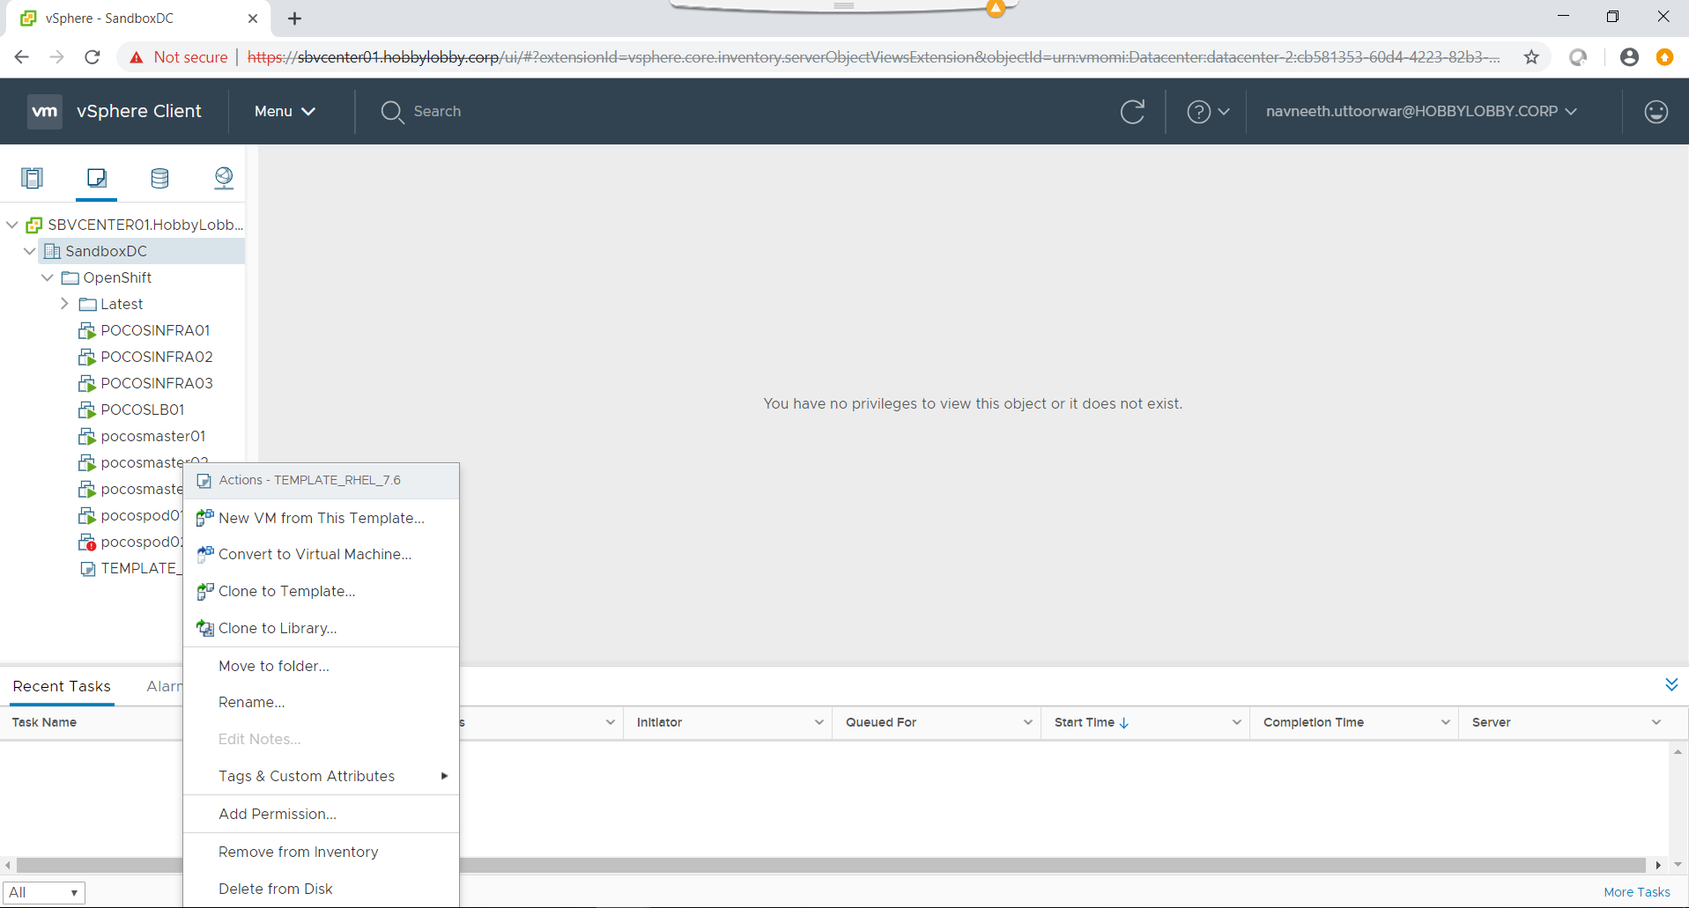

6) You get one new window as TEMPLATE_RHEl_7.6 – Deploy From Template.

**-Name** is the name that you provide for the virtual machine that you're creating.

7) The next step we have select a computer resource.

**Location**: **SBVCENTER01.HobbyLobby.corp/sandboxDC/OpenShift/Latest**

This is where the virtual machine configuration files will be stored.

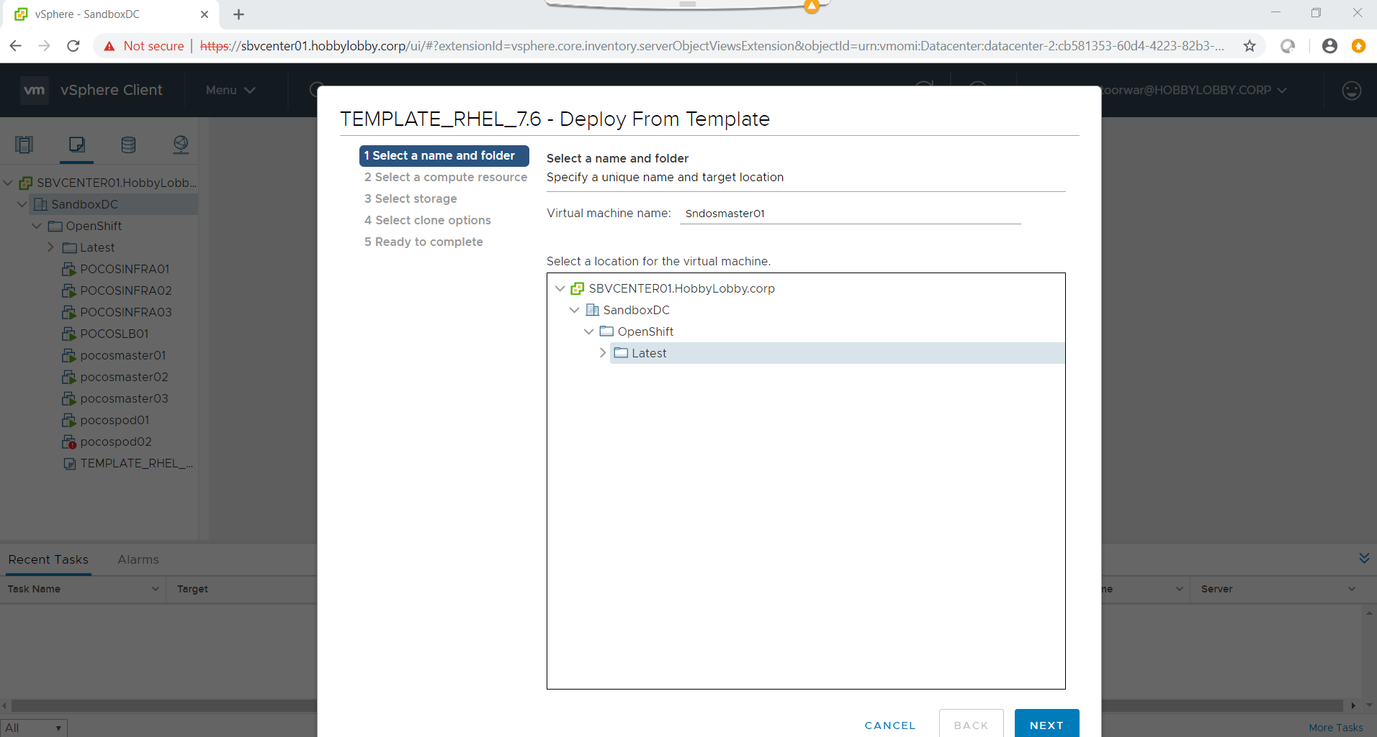

7) Select a computer Resource

SandboxDC > OpenShift cluster

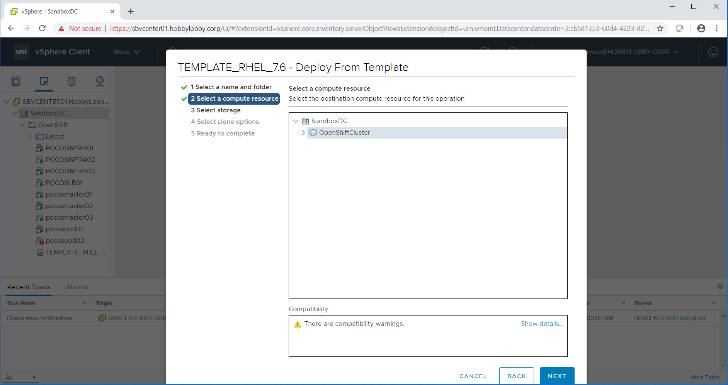

8) **Select the data store which the vm has to be used.**

* Apply a virtual machine storage policy for the virtual machine home files and the virtual disks from the VM storage policy drop-down menu.

The list shows which datastores are compatible and which are incompatible with the selected virtual machine storage policy.

* Select a datastore and click Next.

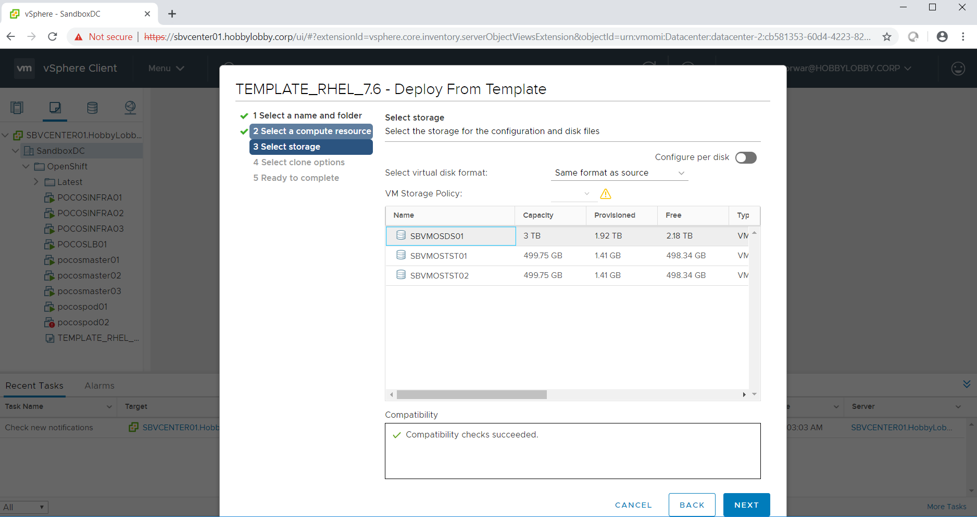

9) Select Clone Options

Here we should select all three check boxes and click Next.

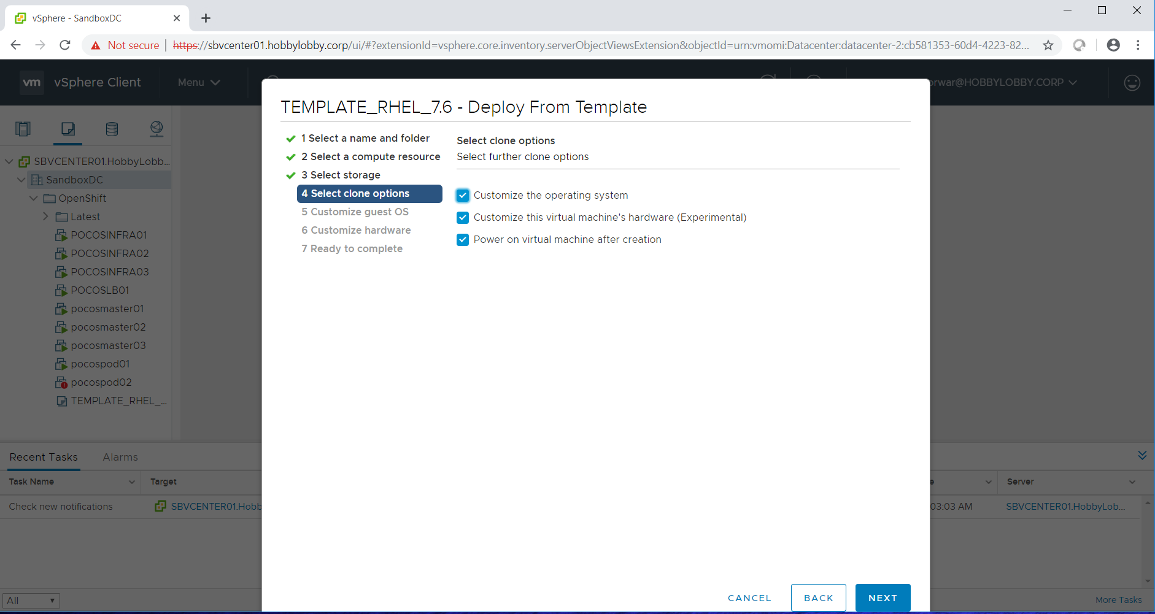

10) Customize guest OS

* Customize the guest OS prevent conflicts when you deploy the virtual machine.
* Operating System: Red Hat Enterprise Linux 7 (64-bit)
* Select the linux and Click Next.

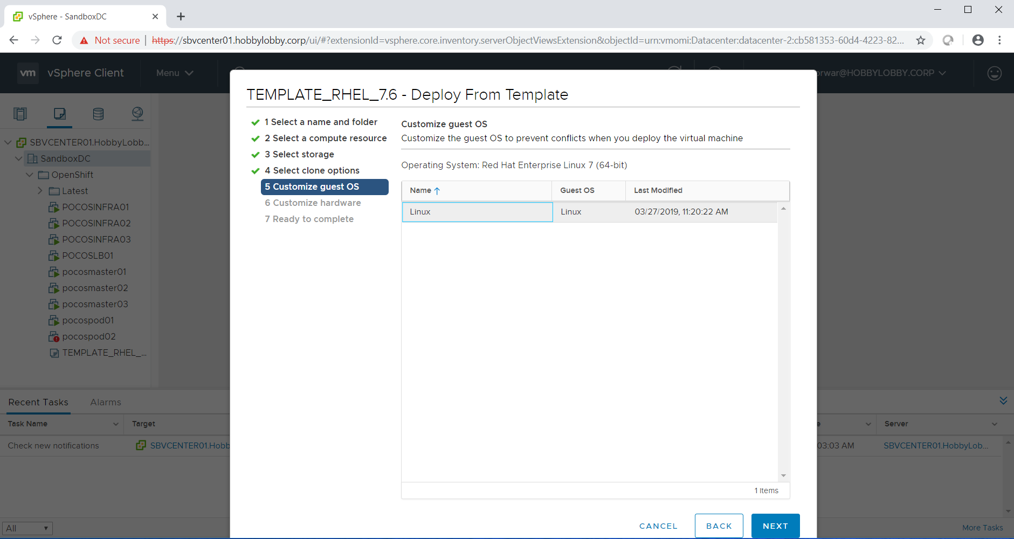

11) User settings: To customize your user specifications, specify the required settings for the virtual machine.

* **IPV4 address** : provide the IP address
* **IPV4 subnet mask**: here we should provide subnet mask.
* **IPV4 default gateway**: It will fill automatically
* **IPV4 alternate gateway**: We can leave blank.
* Click Next

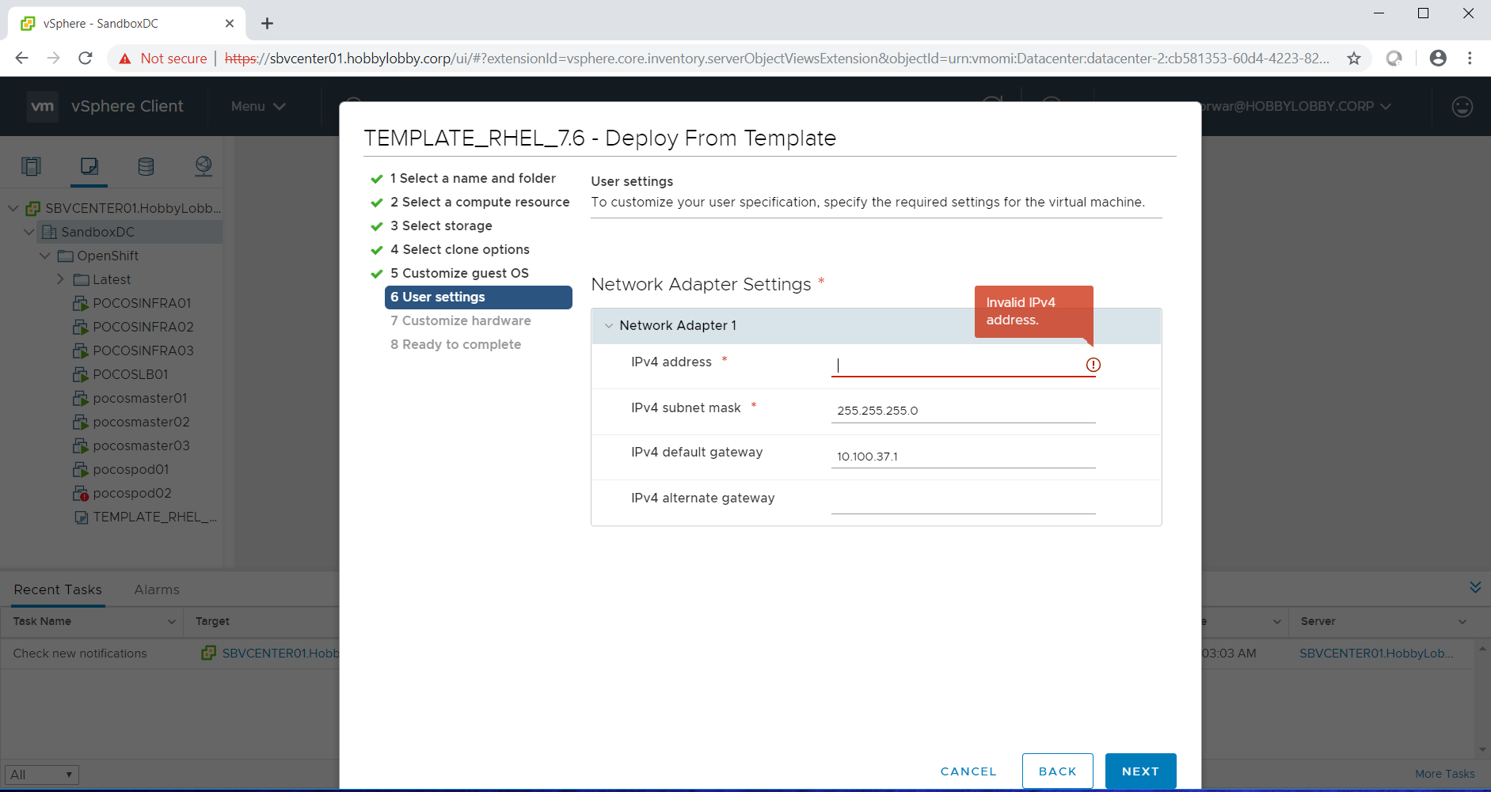

12) **Customize hardware**: Configure the virtual machine hardware.

Edit the vm resources as required (CPU, RAM, MEMORY, NETWORKADAPTOR)

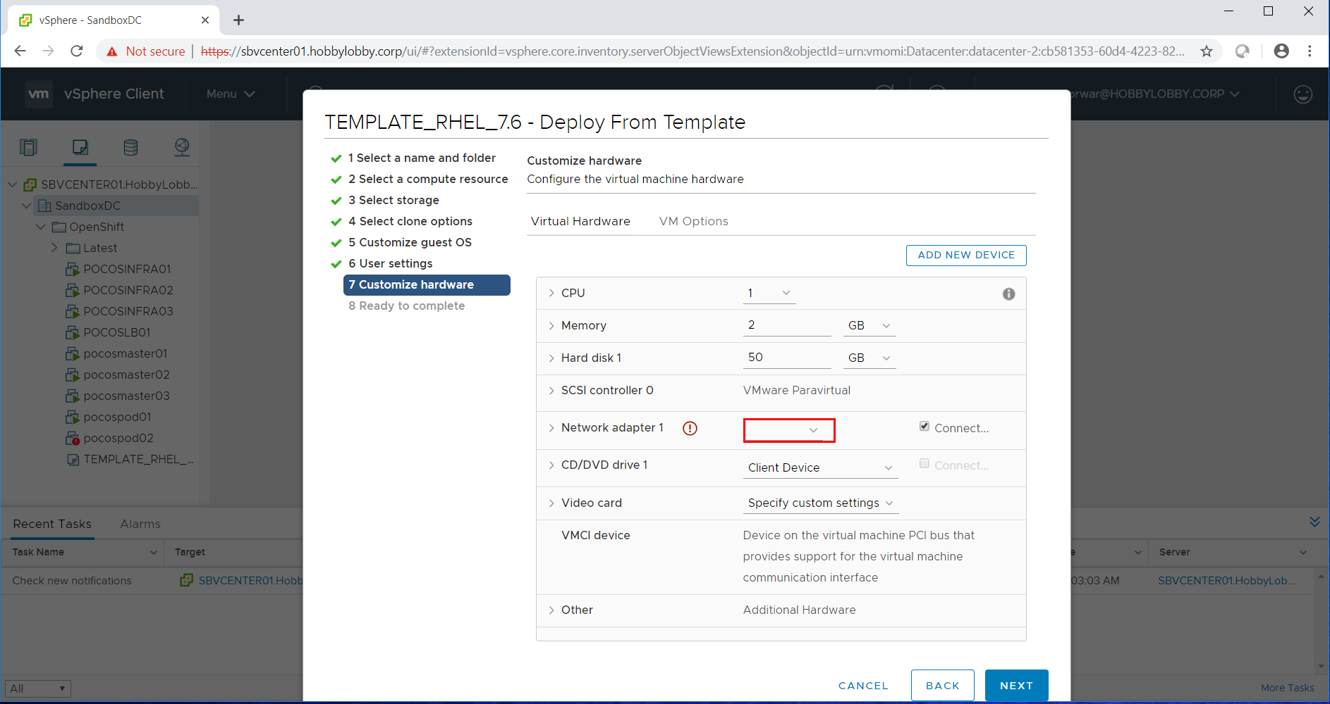

13) Customize hardware: Here we are adding the New Hard disk

* Click on ADD NEW DEVICE select hard Disk.

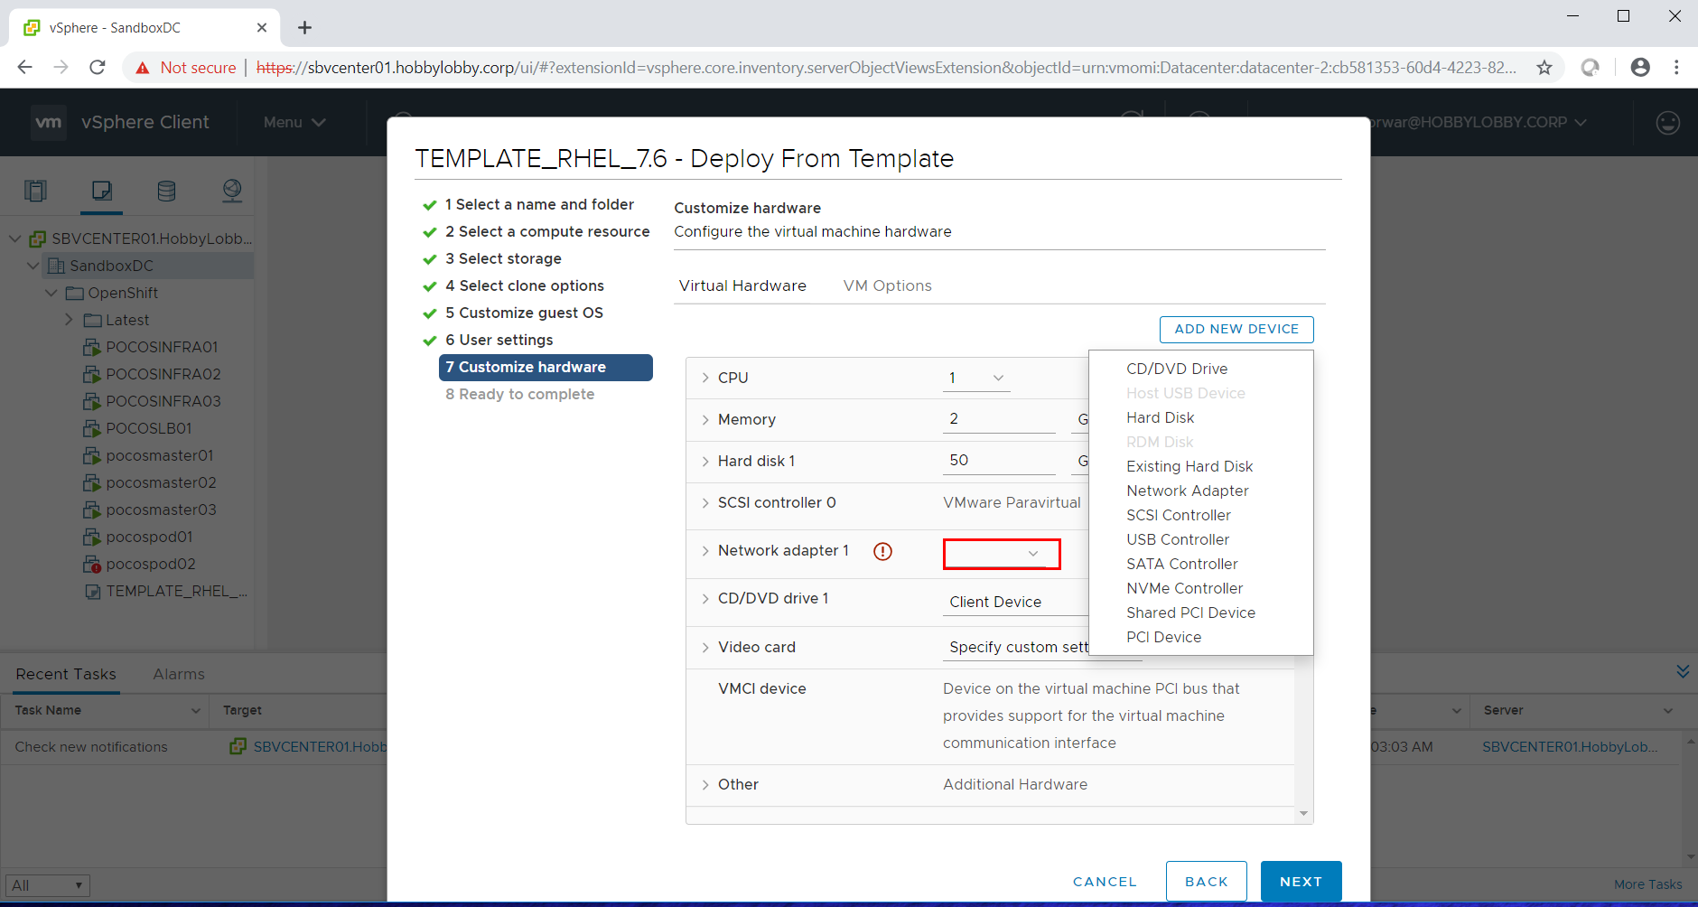

14) Customize hardware: Here you get a New Hard disk.

* Here we can allocate the memory for the usage.

**CPU:** you can select as per your requirement.

**Memory:** you can give as per your requirement.

**Hard disk 1:** 50 GB is fine.

**New Hard disk:** we should provide as per our requirement.

Click NEXT

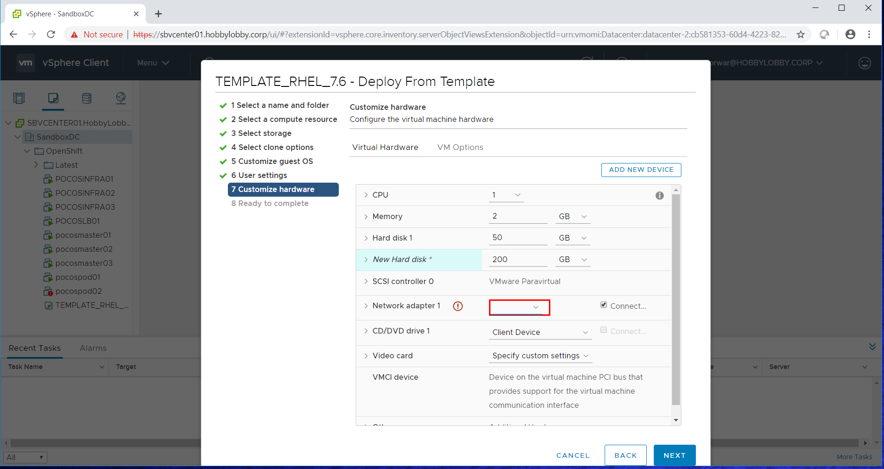

15) Customize hardware: Here we should allocate the Network adapter 1

* Network-related settings for the virtual machine. Click the disclosure arrow to display the settings for this option.
* Click on OK

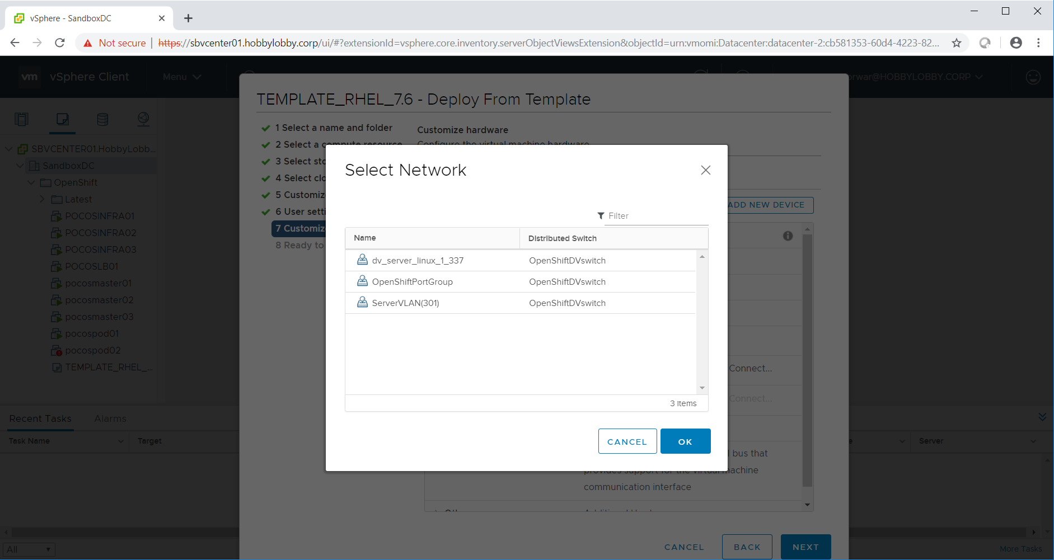

16) Ready to Complete:

Review the given requirement and click finish to start creation.

